Title: | Containerization
Updated: | April 3, 2025 | Due Date: | Midnight before the next class meeting.
Purpose: | The purpose of this lab is to introduce you to containerization concepts and provide hands-on experience with Docker, including installation, container management, networking, and storage. Through guided exercises, you will gain practical knowledge of how to use Docker to deploy and manage applications efficiently across different environments.  This lab addresses competency 5 – install and use containers.
Knowledge: | After completing this lab, you will understand the principles and practical applications of containerization, including how to set up and use Docker for managing containers, volumes, and networks.
Task/Activity: | A. Containerization Introduction  B. Basic Docker Commands  C. Docker Storage  D. Networking  E. Docker Port Mapping  F. Pre-Built Images  G. Reflection
Criteria for Success: | Success in this lab is marked by accurate task completion, effective analysis, documentation, and clear communication of findings. A crucial aspect involves reflecting on the purpose of the lab, linking procedures to broader concepts, and recognizing the lab's significance within the course.  Overall, success is not only measured by technical proficiency but also by critical thinking, effective communication, and a reflective summary that captures the challenges faced and insights gained throughout the lab experience.
- Containerization Introduction
Containerization is a method of packaging software applications and their dependencies into lightweight, portable units called containers. These containers run consistently across different environments, whether on a developer's machine, in testing, or in production. Unlike virtual machines, containers share the host operating system, making them more efficient in terms of resource usage. By isolating applications and their dependencies, containerization ensures that software behaves the same, regardless of where it is deployed. This approach simplifies development, deployment, and scaling while enhancing flexibility and reducing overhead. Tools like Docker and Kubernetes are commonly used for managing containers.

Here is a diagram of the differences between virtual machines and containers.
Container
Virtual Machine
Physical Server
Host Operating System
(Windows, Linux, etc.)
Hypervisor
(VMWare, Hyper-V, etc.)
Guest OS
App A
Bins/Lib
Guest OS
App A
Bins/Lib
Guest OS
App A
Bins/Lib
VM
App A
App A
App B
Physical Server
Host Operating System
(Must be Linux)
Docker
Bins/Lib
Bins/Lib
App B
App B
Container

Docker runs as a service on your machine, allowing you to create and manage containers. Installation varies by operating system (Linux, macOS, or Windows). The instructions listed below show you how to install it on all operating systems. For this lab, we will use the DevOps server that we created in AWS and follow the Linux instructions.
On Windows:
- Download the Docker Desktop application from Docker.com. Run the installer file, making sure to enable the WSL 2 (Windows Subsystem for Linux) option if prompted.
- Launch Docker Desktop.
On MacOS:
- Download the Docker Desktop application from Docker.com. Open the installer and copy the Docker application to the Applications folder.
- Launch Docker. Accept the license agreement, then select the option to “use recommended settings.”
- Click “Finish.”
On Linux:
- We need to add the official Docker repository:
# sudo dnf config-manager --add-repo https://download.docker.com/linux/centos/docker-ce.repo
- Install Docker and needed dependencies:
# sudo dnf install -y docker-ce docker-ce-cli containerd.io docker-compose-plugin
- Start and enable the Docker service:
# sudo systemctl start docker
# sudo systemctl enable docker
- Allow non-root user access (so you don’t have to run sudo every time):
# sudo usermod -aG docker $USER
- Logout and back in for the changes to take effect.
Verify Installation (all operating systems):
- Check the version of Docker that we are running:
docker --version
docker run hello-world
You should have the following:
Hello from Docker!
This message shows that your installation appears to be working correctly.

To generate this message, Docker took the following steps:
1. The Docker client contacted the Docker daemon.
2. The Docker daemon pulled the "hello-world" image from the Docker Hub.
(amd64)
3. The Docker daemon created a new container from that image which runs the
executable that produces the output you are currently reading.
4. The Docker daemon streamed that output to the Docker client, which sent it
to your terminal.
- If you received the above, your Docker installation is working correctly! Paste a screenshot of your terminal with the above text.
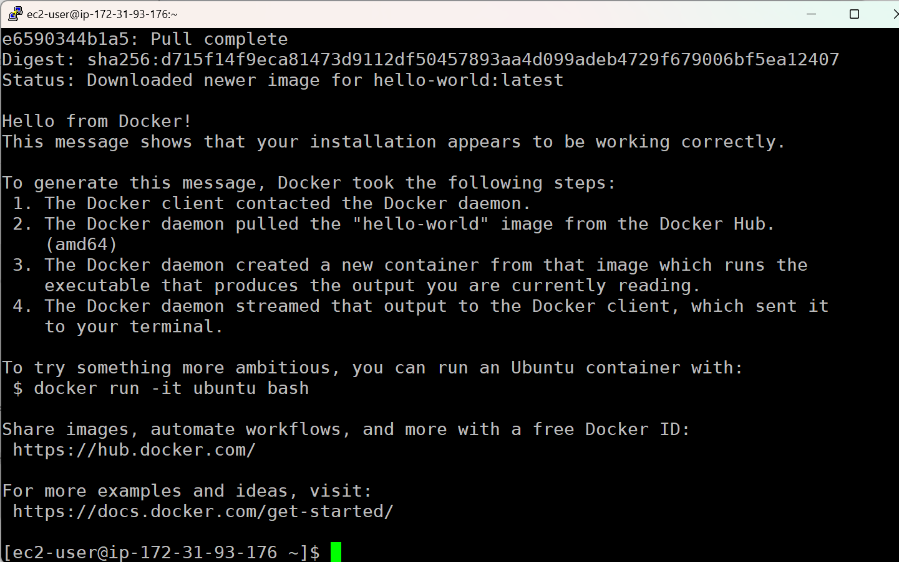
- Basic Docker Commands
Docker has several essential commands to manage containers and images. You will learn commands to pull images, run containers, list running containers, stop and remove containers, and clean up unused resources.
To pull (download) an image to run, the docker pull command is used:
# docker pull hello-world
This pulls the official hello-world image from Docker Hub which has a simple test message, as displayed in the previous section. Note that this does not run the image, just downloads it to be run in the future.
To run an image, the docker run command is used:
# docker run hello-world
This image only runs, outputs the text, then terminates. To verify if it is running, we can use the docker ps command. By default, it only shows active containers. To view all containers, you can add the -a flag to the command.
# docker ps
CONTAINER ID IMAGE COMMAND CREATED STATUS PORTS NAMES
vs
# docker ps -a
CONTAINER ID IMAGE COMMAND CREATED STATUS PORTS NAMES
e9b7bccf7f96 nginx "/docker-entrypoint.…" 8 minutes ago Exited (0) 5 minutes ago modest_shannon
05063c72b0ac nginx "/docker-entrypoint.…" 9 minutes ago Exited (0) 9 minutes ago admiring_mclean
4ce638edab3c alpine "/bin/sh" 10 minutes ago Exited (0) 10 minutes ago clever_heyrovsky
5fdf08247cc6 alpine "/bin/sh" 12 minutes ago Exited (0) 12 minutes ago quizzical_knuth
565ca99e5eda alpine "/bin/sh" 13 minutes ago Exited (0) 13 minutes ago zealous_raman
1b9f8e0292fc hello-world "/hello" 26 minutes ago Exited (0) 26 minutes ago unruffled_jackson
Now that we know the basics, lets download and run a container that will stay running.
- Download the nginx web server container:
# docker pull nginx
Screenshot 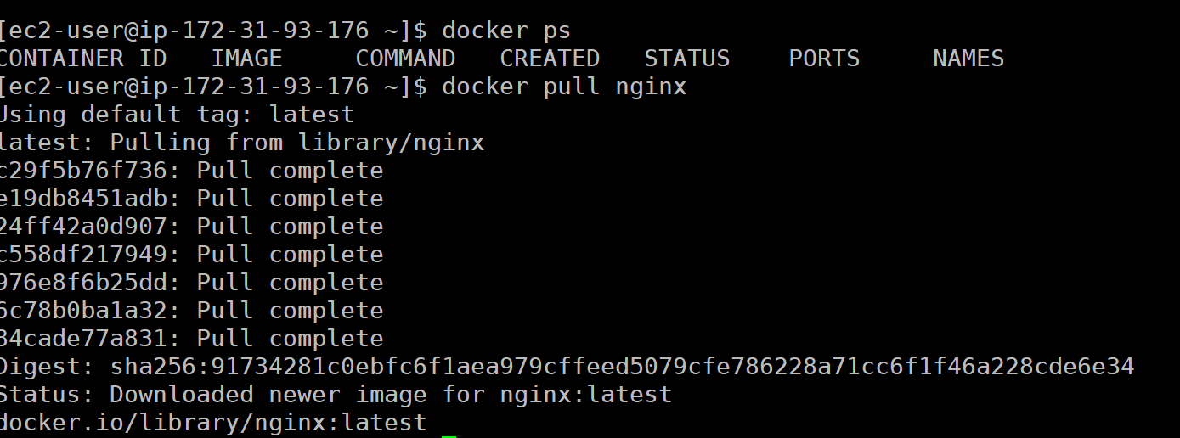
- Run the container:
# docker run -d -p 8080:80 nginx
There are a few flags here that we haven’t covered yet, but we will.
Screenshot 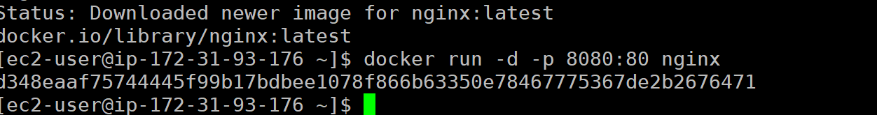

- View the running container with docker ps:
# docker ps
Screenshot 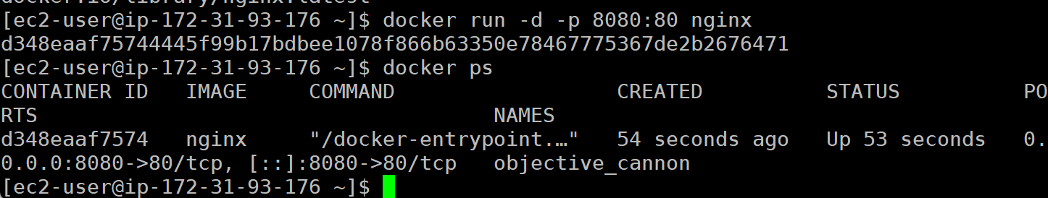
- Verify the nginx web server is running by navigating to your AWS DNS address, on port 8080.
In the browser, it should look something like this (with important parts highlighted):
http://ec2-54-86-242-77.compute-1.amazonaws.com:8080/
Note: If this is not working, make sure that your security group is allowing all TCP from all IPv4 addresses in AWS.
Screenshot 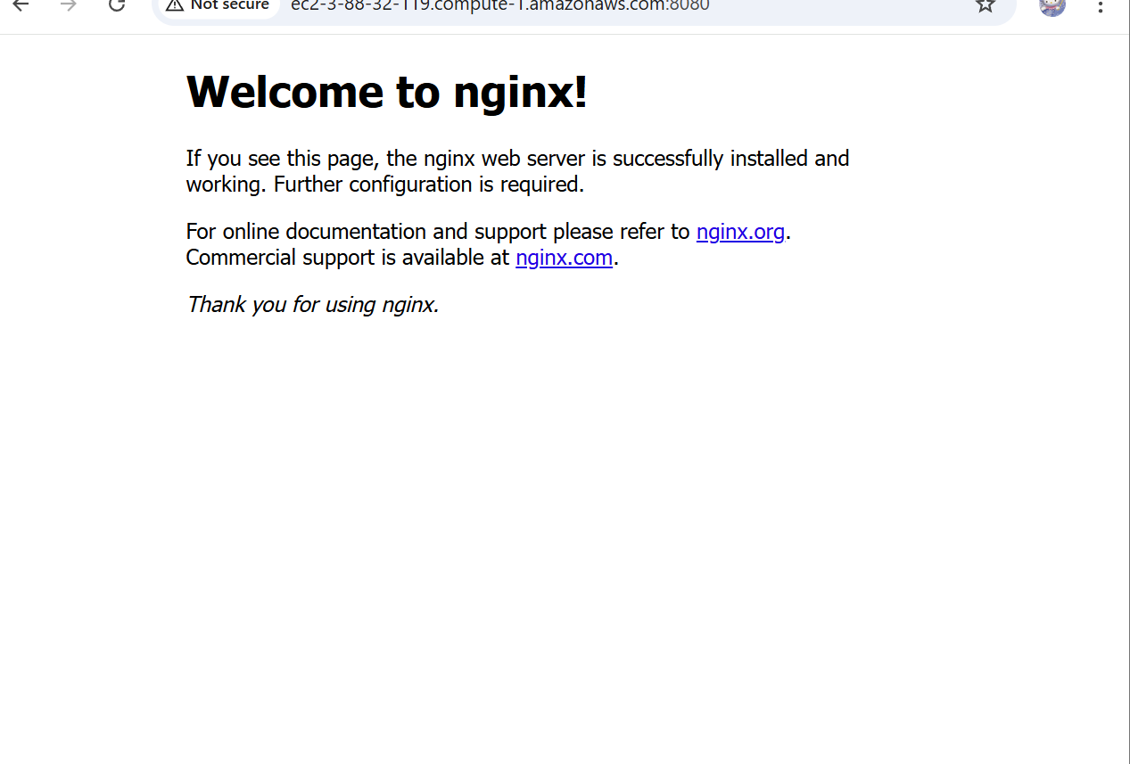
- To stop the container, we use the docker stop command. To do this, we need to get the container ID from the docker ps command:
# docker ps
CONTAINER ID IMAGE COMMAND CREATED STATUS PORTS NAMES
e9b7bccf7f96 nginx "/docker-entrypoint.…" 2 minutes ago Up 2 minutes 0.0.0.0:8080->80/tcp, [::]:8080->80/tcp modest_shannon
# docker stop e9b7bccf7f96 ß Replace this with your container ID
- Verify container was stopped:
# docker ps
or
# docker ps -a
Screenshot 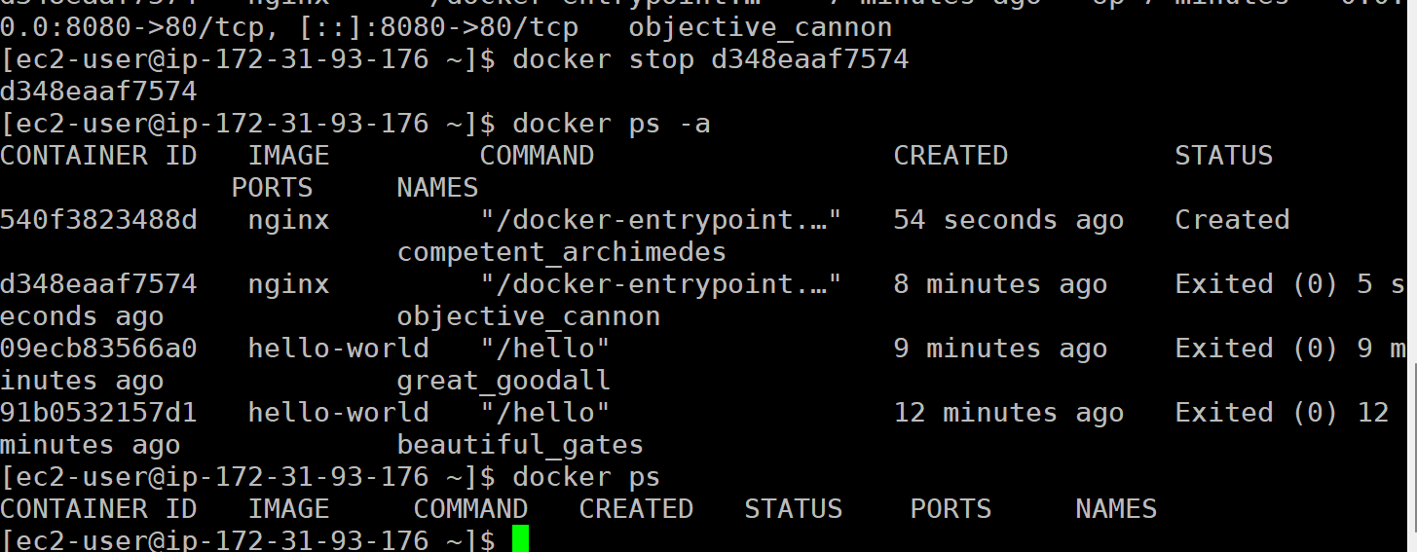
Containers that are no longer used take up valuable space on your system. We can remove unused containers with the docker rm command:
Get the container ID from docker ps -a:
# docker ps -a
CONTAINER ID IMAGE COMMAND CREATED STATUS PORTS NAMES
e9b7bccf7f96 nginx "/docker-entrypoint.…" 52 minutes ago Exited (0) 49 minutes ago modest_shannon
05063c72b0ac nginx "/docker-entrypoint.…" 53 minutes ago Exited (0) 53 minutes ago admiring_mclean
4ce638edab3c alpine "/bin/sh" 53 minutes ago Exited (0) 53 minutes ago clever_heyrovsky
5fdf08247cc6 alpine "/bin/sh" 56 minutes ago Exited (0) 55 minutes ago quizzical_knuth
565ca99e5eda alpine "/bin/sh" 56 minutes ago Exited (0) 56 minutes ago zealous_raman
1b9f8e0292fc hello-world "/hello" About an hour ago Exited (0) About an hour ago unruffled_jackson
For this example, remove the alpine containers:
# docker rm 4ce638edab3c 5fdf08247cc6 565ca99e5eda ß Note that multiple IDs can be specified
Verify they are removed:
# docker ps -a
CONTAINER ID IMAGE COMMAND CREATED STATUS PORTS NAMES
e9b7bccf7f96 nginx "/docker-entrypoint.…" 56 minutes ago Exited (0) 53 minutes ago modest_shannon
05063c72b0ac nginx "/docker-entrypoint.…" 57 minutes ago Exited (0) 57 minutes ago admiring_mclean
1b9f8e0292fc hello-world "/hello" About an hour ago Exited (0) About an hour ago unruffled_jackson
Now that the containers are removed, the image can be managed. To get a list of the images on the system, the docker images command can be used:
# docker images
REPOSITORY TAG IMAGE ID CREATED SIZE
hello-world latest 74cc54e27dc4 43 hours ago 10.1kB
alpine latest b0c9d60fc5e3 2 weeks ago 7.83MB
nginx latest 9bea9f2796e2 8 weeks ago 192MB
To remove the alpine image, the docker rmi (remove image) command can be used:
# docker rmi alpine
Verify the image was removed:
# docker images
REPOSITORY TAG IMAGE ID CREATED SIZE
hello-world latest 74cc54e27dc4 43 hours ago 10.1kB
nginx latest 9bea9f2796e2 8 weeks ago 192MB
Now that you know the steps to work with Docker containers, show off what you know.
- Get the ID of the nginx container on your system.
Command(s) used: | Docker ps -a
Screenshot of commands being run: | 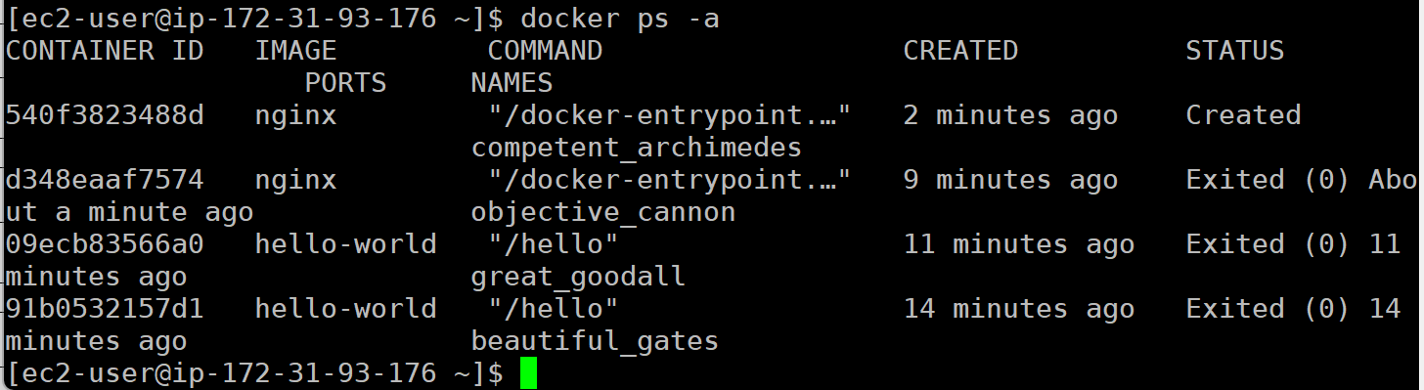
- Remove the nginx container.
Command(s) used: | Docker rm d348eaaf7574
Screenshot of commands being run: | 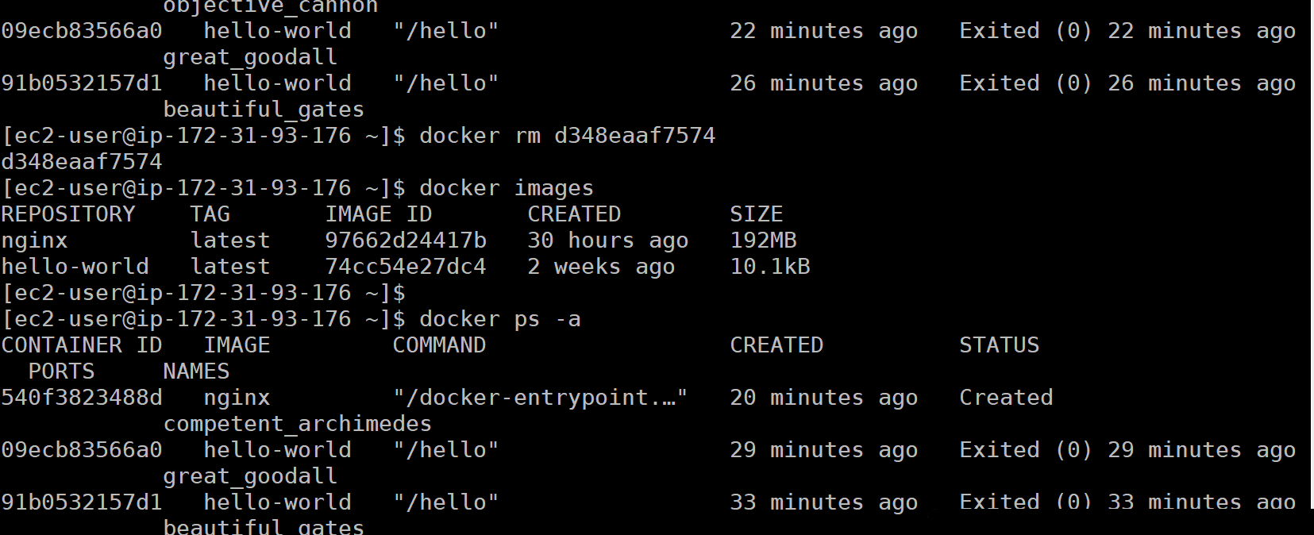
- List the images on your system.
Command(s) used: | Docker image list
Screenshot of commands being run: | 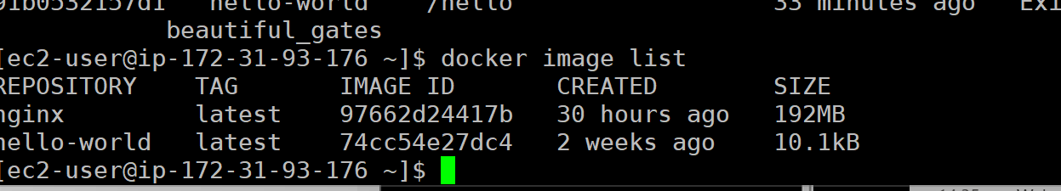
- Remove the nginx image.
Command(s) used: | Docker rmi nginx
Screenshot of commands being run: | 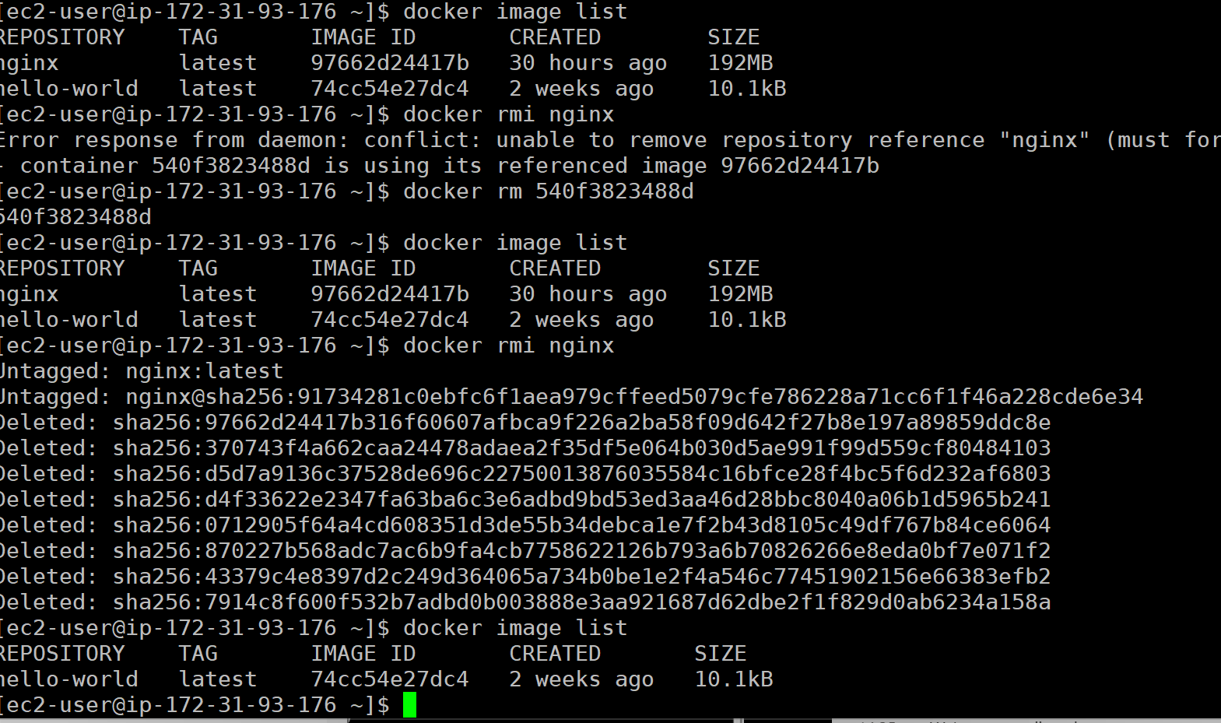
- Verify removal.
Command(s) used: | Docker images
Screenshot of commands being run: | 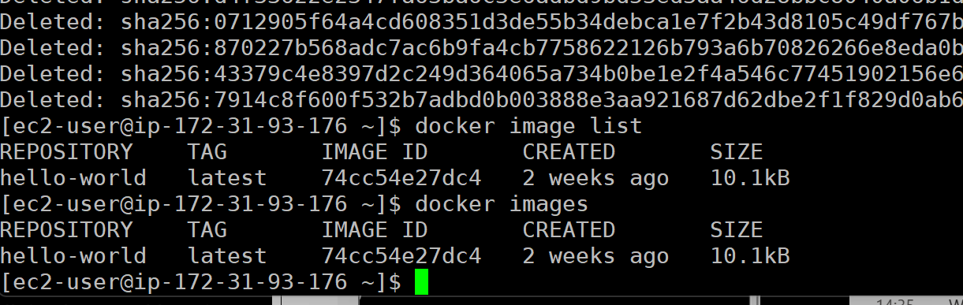
- Docker Storage
So far, we have just pulled images from Docker Hub and then ran them with no modifications. In most cases, you will want to attach storage to the container for log files, web pages that you are serving, configuration files that you might update but want to stay the same between container versions, or many other reasons.
Docker storage comes in three varieties:
- Temporary storage - storage that is inside of the container. This only remains while the container is active - once the container is deleted (not stopped, files are retained then), the files or folders are deleted along with it.
- Volumes - storage that is self-contained and can be connected to a container. Portable, easy to backup or share between containers.
- Bind mounts - storage that is a folder on your system that you want accessible from the container. This is usually accomplished by mapping the folder to a folder inside of the container.
Let’s start with the temporary storage.
- Run a container and write a file inside of it.
# docker run -it --name storage-test ubuntu
This command uses a couple new flags. -it starts an interactive terminal (allowing you to interact with it directly), --name allows you to specify a name for the container, which is easier to use than the container ID we have been working with. This will allow us to run commands like docker stop storage-test instead of docker stop 74cc54e27dc4.
You are now inside of the container running commands there and not directly in your system. You can tell since the terminal has changed:
[ec2-user@ip-172-31-25-67 ~]$ docker start -it --name storage-test ubuntu
root@1c61eef51175:/#
The diagram at the beginning of this lab is a good visual aid to understand where you are in the system running things.
- From inside the container, create a file:
# echo “Hello from Docker!” > /tmp/hello.txt ß This will add Hello from Docker! Into a file in /tmp/hello.txt
# exit ß This will exit the container, and stop it since you are exiting it
- Verify the container has stopped with docker ps -a:
# docker ps -a
CONTAINER ID IMAGE COMMAND CREATED STATUS PORTS NAMES
1c61eef51175 ubuntu "/bin/bash" 4 minutes ago Exited (0) 4 seconds ago storage-test
- Start the same container again:
# docker start -i storage-test
Note that we are using the name we assigned earlier and docker start command instead of docker run. Once a container has been started and stopped, unless we want to create a whole new container instance, we can just start the previous one.
- We will use the cat command to output the contents of the file in the /tmp directory:
# cat /tmp/hello.txt
Hello from Docker!
This should output the text you put in there in step 2.
- Exit, stop, and remove the storage-test container.
Temporary storage should not be used for anything in production, or that you want to keep long term.
Next, we will talk about volume storage. Docker volume storage is a method for persisting data generated or used by Docker containers, allowing it to survive container restarts or deletions. Volumes are managed by Docker and stored outside the container's filesystem, typically in a specific directory on the host machine (/var/lib/docker/volumes by default). This separation ensures data remains accessible across container lifecycles or when sharing data between containers. Volumes are flexible, enabling efficient backups, sharing, and scaling while keeping the container lightweight and stateless.
To use a volume, it needs to be created. To do this, we use the docker volume create command:
# docker volume create my-data ß my-data here is the name of the volume. It can be anything
Once the volume is created, it can be attached to a container at runtime:
# docker run -id -v my-data:/data --name volume-test ubuntu
Once again, we have some new flags to understand. The -id runs the container detached (will keep running in the background and not block your terminal access). -v specifies a volume to mount, in this case my-data, which is connected to the /data folder inside of the container. Any data written into /data will be written to and stored in the my-data volume.
Running the docker ps command will show that the container is running in the background.
# docker ps
CONTAINER ID IMAGE COMMAND CREATED STATUS PORTS NAMES
b95be1d0c784 ubuntu "/bin/bash" 3 seconds ago Up 3 seconds volume-test
To access the container and run commands inside of it, we can run the docker exec command.
# docker exec -it {container name or ID} bash
This executes the bash (bash) shell interactively (-it) in the container. We should have the changed prompt.
root@b95be1d0c784:/#
If we create a file in the /data directory (which is where we attached our volume), it should be stored in the volume and not in the container itself.
root@b95be1d0c784:/# touch /data/volume-file.txt
root@b95be1d0c784:/# ls /data
volume-file.txt
Exit the container with exit, stop the container with docker stop, and delete the container with docker rm.
root@b95be1d0c784:/# exit
# docker stop volume-test
# docker rm volume-test
Verify it is deleted with docker ps -a.
# docker ps -a
CONTAINER ID IMAGE COMMAND CREATED STATUS PORTS NAMES
e9b7bccf7f96 nginx "/docker-entrypoint.…" 56 minutes ago Exited (0) 53 minutes ago modest_shannon
05063c72b0ac nginx "/docker-entrypoint.…" 57 minutes ago Exited (0) 57 minutes ago admiring_mclean
1b9f8e0292fc hello-world "/hello" About an hour ago Exited (0) About an hour ago unruffled_jackson
The container is gone, let’s check if the volume still exists.
# docker volume ls
DRIVER VOLUME NAME
local my-data
It does! Now, create a new container with the volume attached and see if our file is still there.
# docker run -id -v my-data:/data --name volume-test2 ubuntu
Enter the container.
# docker exec -it volume-test2 bash
root@18cbaceda937:/#
List the files in the /data directory.
root@18cbaceda937:/# ls /data
volume-file.txt
Our file is still there!
Exit, stop, and remove the volume-test2 container.
root@18cbaceda937:/# exit
# docker stop volume-test2
# docker rm volume-test2
# docker ps -a
CONTAINER ID IMAGE COMMAND CREATED STATUS PORTS NAMES
e9b7bccf7f96 nginx "/docker-entrypoint.…" 56 minutes ago Exited (0) 53 minutes ago modest_shannon
05063c72b0ac nginx "/docker-entrypoint.…" 57 minutes ago Exited (0) 57 minutes ago admiring_mclean
1b9f8e0292fc hello-world "/hello" About an hour ago Exited (0) About an hour ago unruffled_jackson
To delete the volume, the docker volume rm command is used. List the volumes first, then delete, then verfy.
# docker volume list
DRIVER VOLUME NAME
local my-data
# docker volume rm my-data
# docker volume list
DRIVER VOLUME NAME
Note: volumes can only be deleted when they are not in use.
Let’s get some practice with volumes.
- Create a volume called my-volume.
Command(s) used: | Docker volume create my-volume
Screenshot of commands being run: | 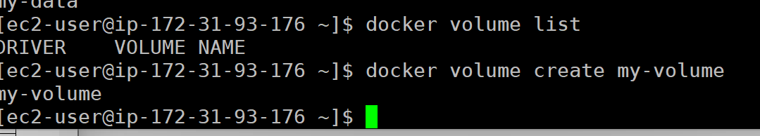
- Attach the my-volume volume to a new ubuntu container named volume-container attached to the /volume folder in the container.
Command(s) used: | docker run -id -v my-volume:/volume --name volume-container ubuntu
Screenshot of commands being run: | 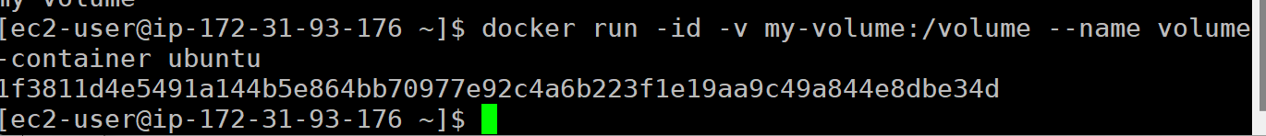
- Go into the container (docker exec) and create a file named your-name.txt (I would create tage.txt) in the /volume folder.
Command(s) used: | Docker exec –it volume-container bash  Touch /volume/Daniela.txt  Ls /volume
Screenshot of commands being run: | 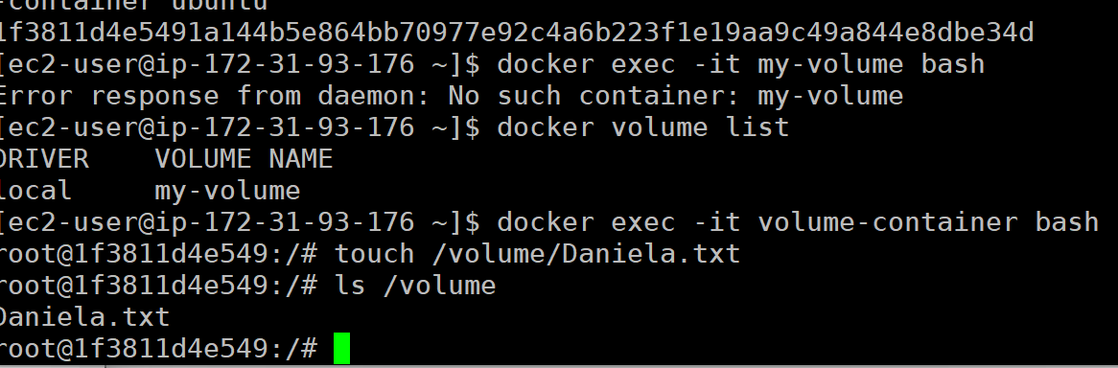
- Exit the container.
Command(s) used: | Exit
Screenshot of commands being run: | 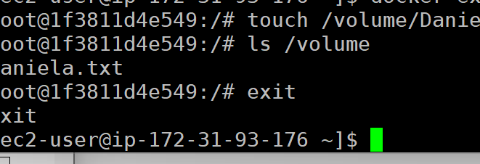
- Stop and delete the container.
Command(s) used: | Docker stop volume-container  Docker rm volume container
Screenshot of commands being run: | 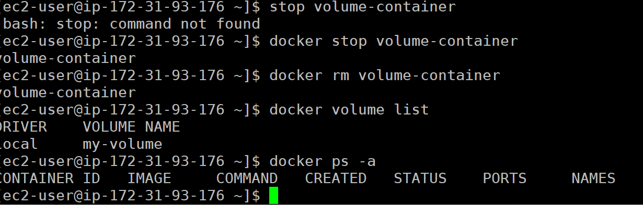
- Create a new ubuntu container called volume-container2 with the volume my-volume attached to the /volume folder.
Command(s) used: | docker run -id -v my-volume:/volume --name volume-container2 ubuntu
Screenshot of commands being run:
- Go into the container and list the contents of the /volume folder.
Command(s) used: | Ls /volume
Screenshot of commands being run: | 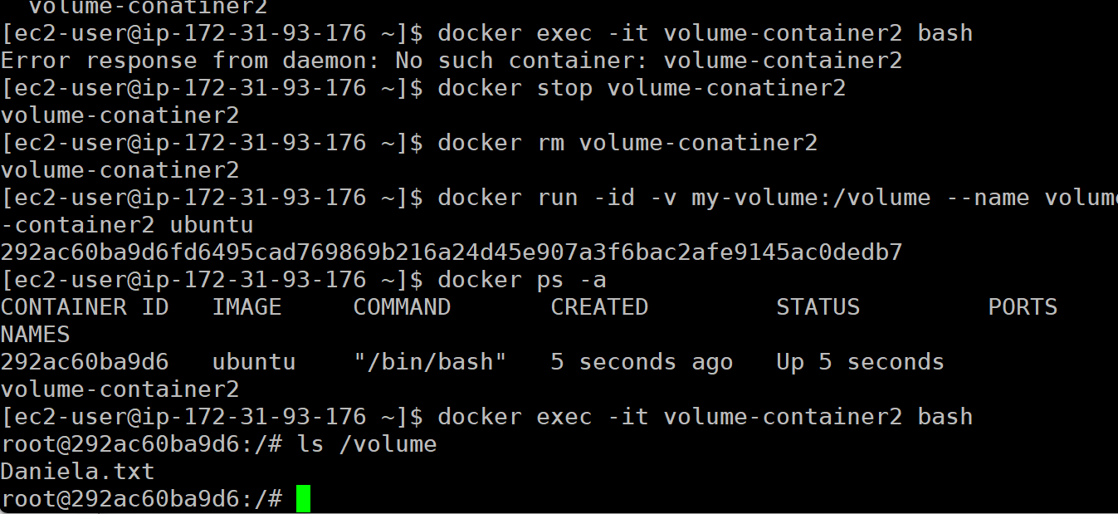
- Exit, stop, and delete the container.
Command(s) used: | Exit  Docker stop volume-container2  Docker rm volume-container2
Screenshot of commands being run: | 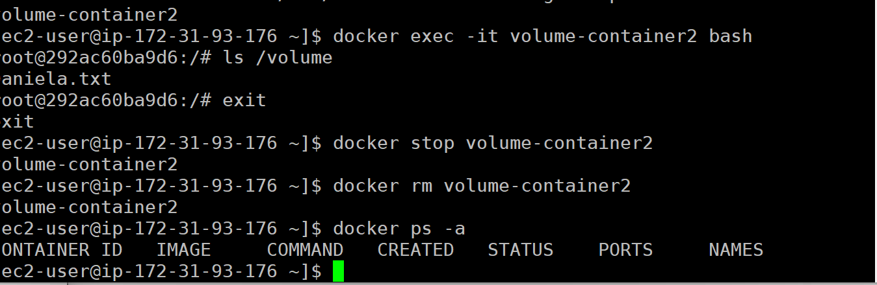
- Delete the my-volume volume.
Command(s) used: | Docker volume rm my-volume
Screenshot of commands being run: | 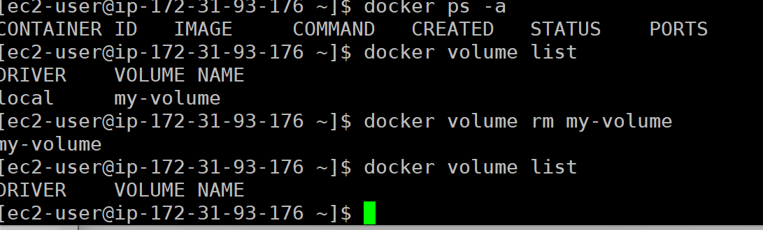
- Networking
A very important part of Docker is the networking features. Docker networking is the system that enables containers to communicate with each other, the host machine, and external networks. It uses different network drivers to configure how containers interact, such as the default bridge network for isolated communication on a single host, the host network for direct access to the host's network stack, and the overlay network for multi-host container communication in distributed environments. Docker networking also provides tools for custom networks, ensuring secure, efficient, and flexible connectivity. Each container is assigned an IP address, and services can resolve each other by name when connected to the same network.
A list of current networks can be viewed with the docker network ls command.
# docker network ls
NETWORK ID NAME DRIVER SCOPE
bfa8e335820f bridge bridge local
5b30fdfc57bb host host local
fe094df3321e none null local
By default, there are three networks. The bridge network is a private network for containers on the same host (server). Containers on the same bridge network can communicate with each other using their container names.
To create a new bridge network, the docker network create command is used.
# docker network create my-bridge
Verify the creation with the docker network ls command.
# docker network ls
NETWORK ID NAME DRIVER SCOPE
bfa8e335820f bridge bridge local
5b30fdfc57bb host host local
1af015cc9d39 my-bridge bridge local
fe094df3321e none null local
To add containers to the network, specify the network name with the --network flag.
# docker run -id --network my-bridge --name container-1 ubuntu
This will run a single container on the my-bridge network. Add a second container the same way.
# docker run -id --network my-bridge --name container-2 ubuntu
Verify that we have them both running.
# docker ps
CONTAINER ID IMAGE COMMAND CREATED STATUS PORTS NAMES
72c7036d6a5e ubuntu "/bin/bash" 2 seconds ago Up 2 seconds container-2
bd0fb7ba3039 ubuntu "/bin/bash" 43 seconds ago Up 42 seconds container-1
To view the containers attached to a network, the docker network inspect command can be used.
# docker network inspect my-bridge
This outputs a lot of information in a JSON format. I have highlighted some important parts below.
[
Name of the network
{
"Name": "my-bridge",
"Id": "1af015cc9d390d5fd612cf7e613d22f391c0272540005972f1158b54d32e4f73",
"Created": "2025-01-24T16:21:00.137407434Z",
"Scope": "local",
Type of network
"Driver": "bridge",
"EnableIPv6": false,
"IPAM": {
"Driver": "default",
"Options": {},
"Config": [
{
IP Address Scope
"Subnet": "172.18.0.0/16",
"Gateway": "172.18.0.1"
}
]
},
"Internal": false,
"Attachable": false,
"Ingress": false,
"ConfigFrom": {
List of containers attached to the network
"Network": ""
},
"ConfigOnly": false,
"Containers": {
"72c7036d6a5ee5e83d3284c45f8bb963ac4021e9a282cf2dc57a3b3618e0ea41": {
"Name": "container-2",
"EndpointID": "73a230e025790ef1d43b37dc33f6150589ca3930ba697fa7af5279e8fdfdf9b3",
"MacAddress": "02:42:ac:12:00:03",
IP Address assigned to the container
"IPv4Address": "172.18.0.3/16",
"IPv6Address": ""
},
"bd0fb7ba3039840fa6015ca5e9b9a4297c6fcd17c7f258242b4d6fe65bca8124": {
"Name": "container-1",
"EndpointID": "89f3ec93bac9802781412524e8f34384880e142ac91a5d18ae2963e45a7ab861",
"MacAddress": "02:42:ac:12:00:02",
"IPv4Address": "172.18.0.2/16",
"IPv6Address": ""
}
},
"Options": {},
"Labels": {}
}
]
There is also the ability to connect a single container to multiple networks, or change the network while the container is running. This is done with the docker network connect and docker network disconnect commands.
To connect a container to another network:
# docker network connect {network name} {container name or ID}
To connect container-1 to the bridge network, the command would be:
# docker network connect bridge container-1
To disconnect container-1 from the network bridge, the command would be:
# docker network disconnect bridge container-1
To demonstrate the communication between the two containers on the my-bridge network, we can enter container-1 and ping container-2:
# docker exec -it container-1 bash
root@bd0fb7ba3039:/#
By default, the ubuntu container image is very sparse and has almost nothing running on it. We will need to install the ping utility to test the connectivity.
root@bd0fb7ba3039:/# apt install -y iputils-ping
root@bd0fb7ba3039:/# ping container-2 -c 4 ß Adding the -c 4 to this command stops ping after 4 replies
PING container-2 (172.18.0.3) 56(84) bytes of data.
64 bytes from container-2.my-bridge (172.18.0.3): icmp_seq=1 ttl=64 time=0.024 ms
64 bytes from container-2.my-bridge (172.18.0.3): icmp_seq=2 ttl=64 time=0.060 ms
64 bytes from container-2.my-bridge (172.18.0.3): icmp_seq=3 ttl=64 time=0.060 ms
64 bytes from container-2.my-bridge (172.18.0.3): icmp_seq=4 ttl=64 time=0.055 ms

--- container-2 ping statistics ---
4 packets transmitted, 4 received, 0% packet loss, time 3052ms
rtt min/avg/max/mdev = 0.024/0.049/0.060/0.015 ms
Notice that we could also ping container-2’s IP address of 172.18.0.3 in this case. We could see this information in the output of the docker network inspect command above.
To delete the network, exit the container and use the docker network rm command. Note: Any containers connected to the network must be removed before you can delete the network.
# docker network rm my-bridge
You can verify the network was removed with the docker network ls command.
- Create a new bridge network called lab-6-network.
Command(s) used: | docker network create lab-6-network
Screenshot of commands being run: | 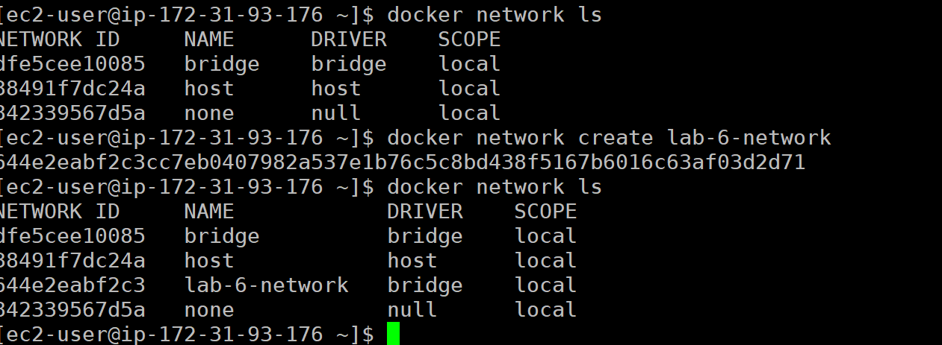
- Create containers container-1 and container-2 using the ubuntu image.
Command(s) used: | docker run -id --network lab-6-network --name container-1 ubuntu  docker run -id --network lab-6-network --name container-2 ubuntu
Screenshot of commands being run: | 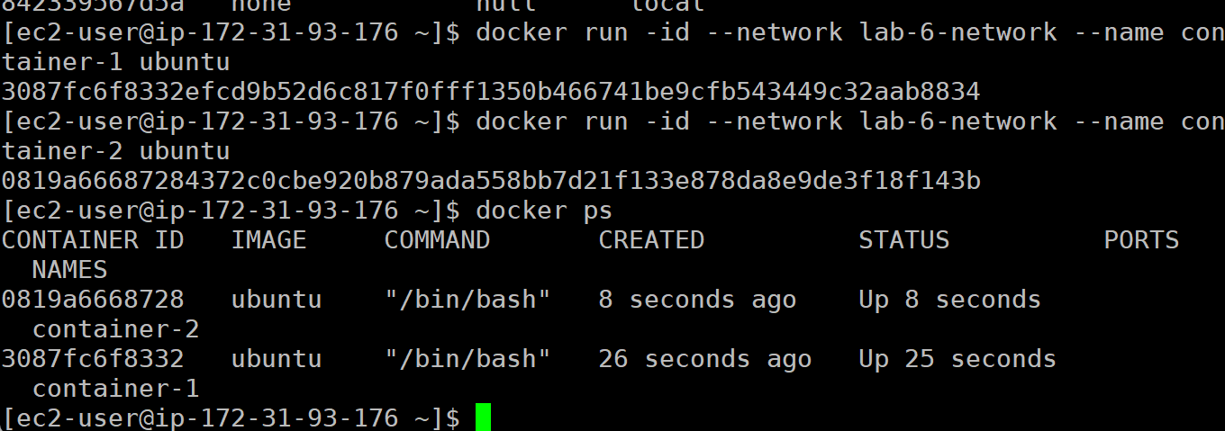
- Add container-1 and container-2 to the lab-6-network.
Command(s) used: | Already connected in the previous step
Screenshot of commands being run:
- Inspect the lab-6-network to get the IP address of container-2.
Command(s) used: | Docker network inspect lab-6-network
Screenshot of commands being run: | 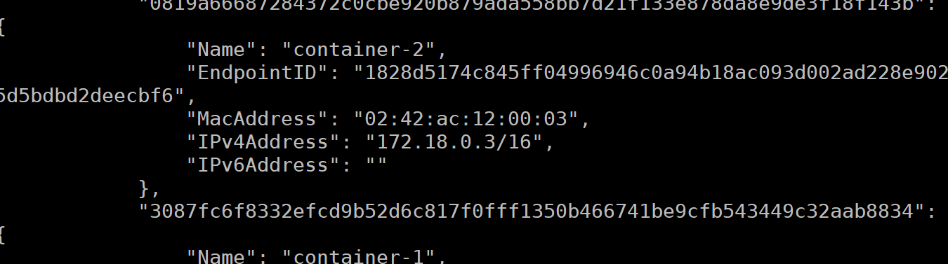
- Go into container-1 and ping container-2 by the container name.
Command(s) used: | docker exec -it container-1 bash  ping container-2 –c 5
Screenshot of commands being run: | 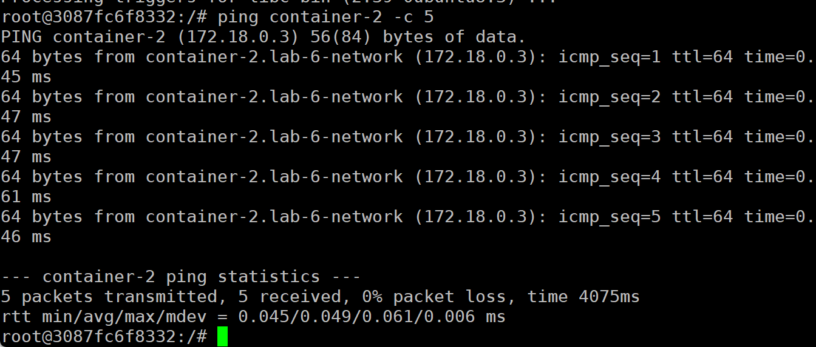
- Ping container-2 by the IP address you got in step 4.
Command(s) used: | Ping 172.18.0.3 -c 5
Screenshot of commands being run: | 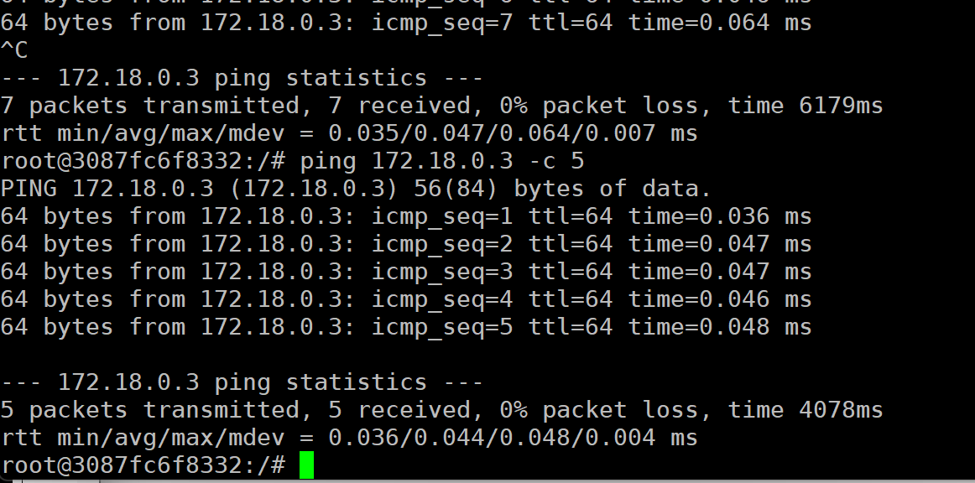
- Exit, stop, and delete container-1 and container-2.
Command(s) used: | exit  docker stop container-1  docker rm container-2
Screenshot of commands being run: | 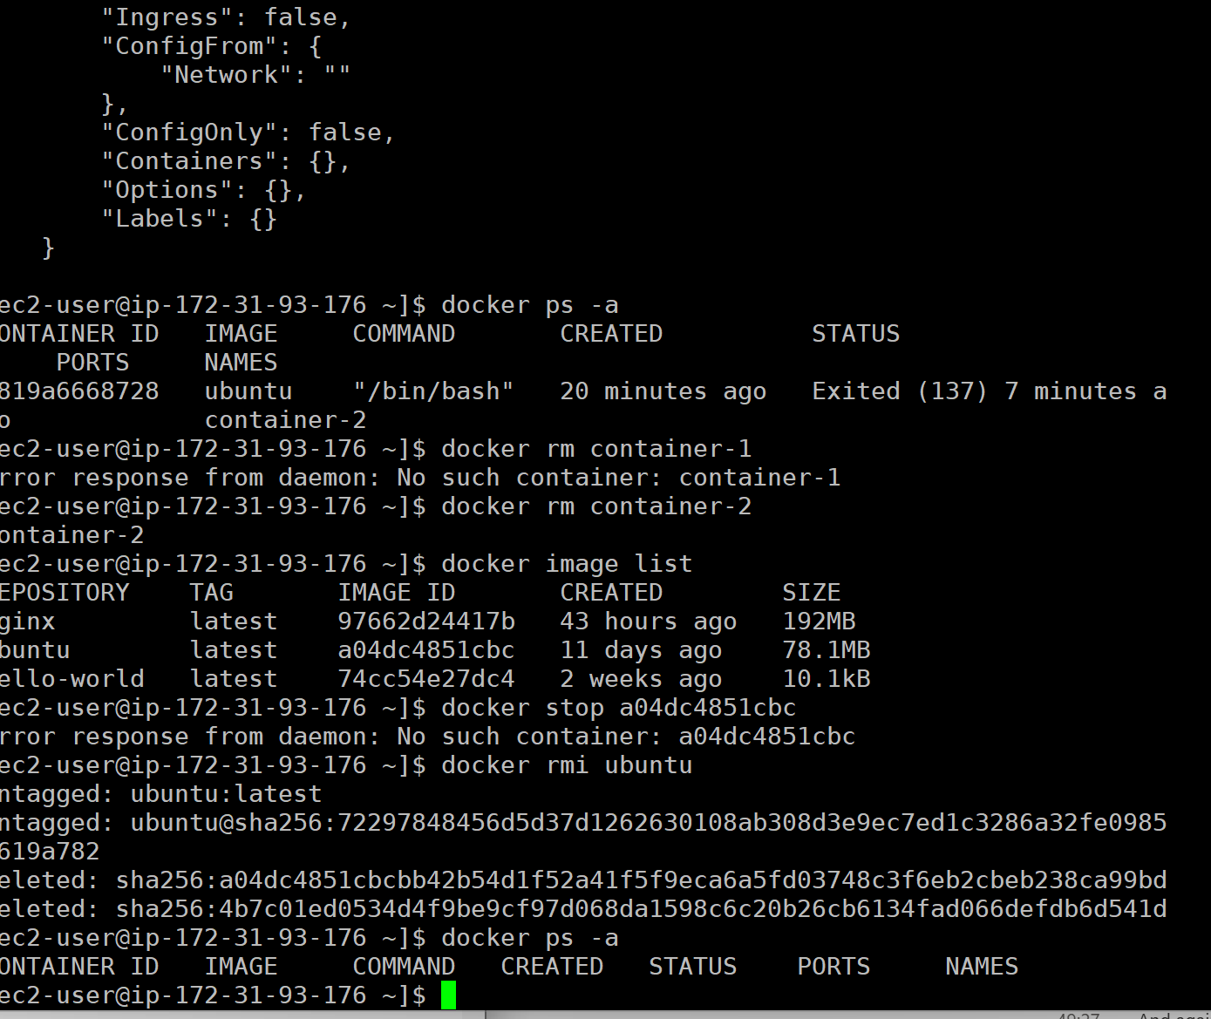
- Remove the lab-6-network.
Command(s) used: | docker network rm lab-6-network
Screenshot of commands being run: | 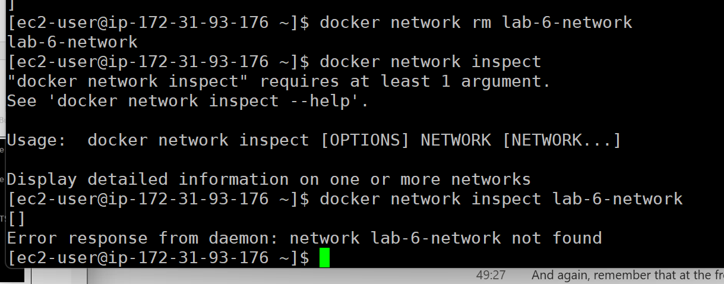
The host network connects your Docker container directly to the network that your host (server) machine is using. It is effectively connecting an ethernet cable directly to the container. You connect this network to the container just like in the last steps:
# docker network connect host {container name or ID}
The host network is best used if you need network performance, or to not have anything in the way of your network connection. Some applications require full, direct network access. This would be the network to use for that.
An overlay network in Docker is a virtual network that enables containers running on different Docker hosts to communicate securely as if they were on the same local network. It works by creating a software-defined layer over the physical network, connecting multiple hosts in a Docker Swarm or Kubernetes cluster. Overlay networks are commonly used for distributed applications or microservices, as they allow seamless inter-host communication while isolating the network traffic from other systems.
Overlay networks are beyond the scope of this course. If you are interested in learning more about them, and some more advanced Docker functionality, I recommend that you check out the Docker documentation at https://docs.docker.com/
- Docker Port Mapping
Docker port mapping is the process of connecting ports on a container to ports on the host machine, enabling external access to services running inside the container. When a container is started, the -p or --publish flag is used to map a host port to a container port in the format host_port:container_port. For example, -p 8080:80 maps port 80 in the container to port 8080 on the host. This allows users to access the containerized service via the host's IP address or domain and the specified host port.
One of the most common uses of port mapping is a web server. HTTP (non-secure) runs on port 80. HTTPS (secure) runs on port 443. To run a nginx container and have the port “exposed” for users, we need to map it to a host port.
To accomplish this, the docker run command would look like this:
# docker run -d -p 8080:80 nginx
This will run the nginx docker pre-built image and expose the container HTTP port (80) to a non-standard port on the host (8080).
If you need to map multiple ports to a container, you can add more -p options:
# docker run -d -p 8080:80 -p 1234:22 nginx
- Start a nginx pre-built container and map the container’s port 80 to the hosts port 4837.
Command(s) used: | docker run -d -p 4837:80 nginx
Screenshot of commands being run: | 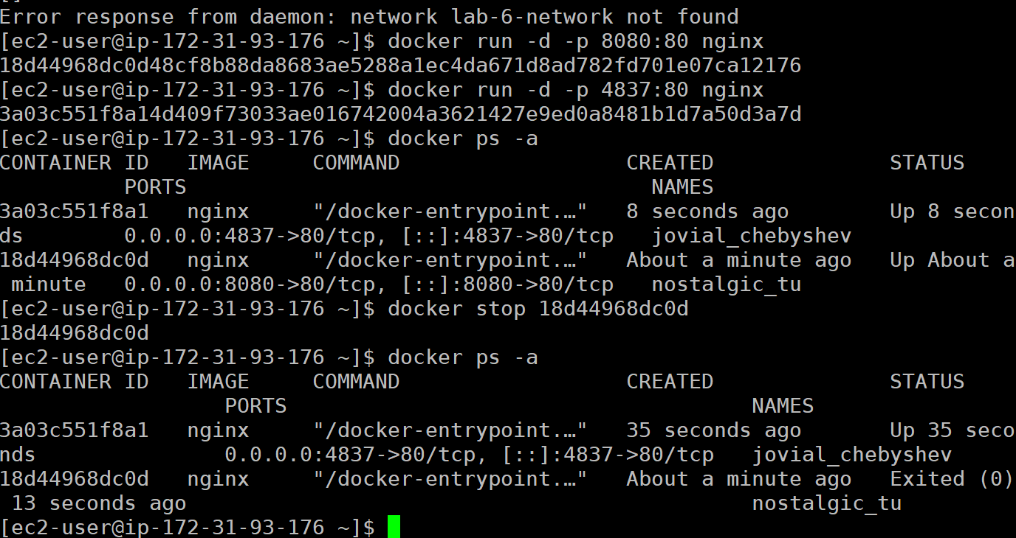
- Navigate to your instance DNS address on port 4837 to confirm nginx is accessible.
Screenshot of nginx in browser: | 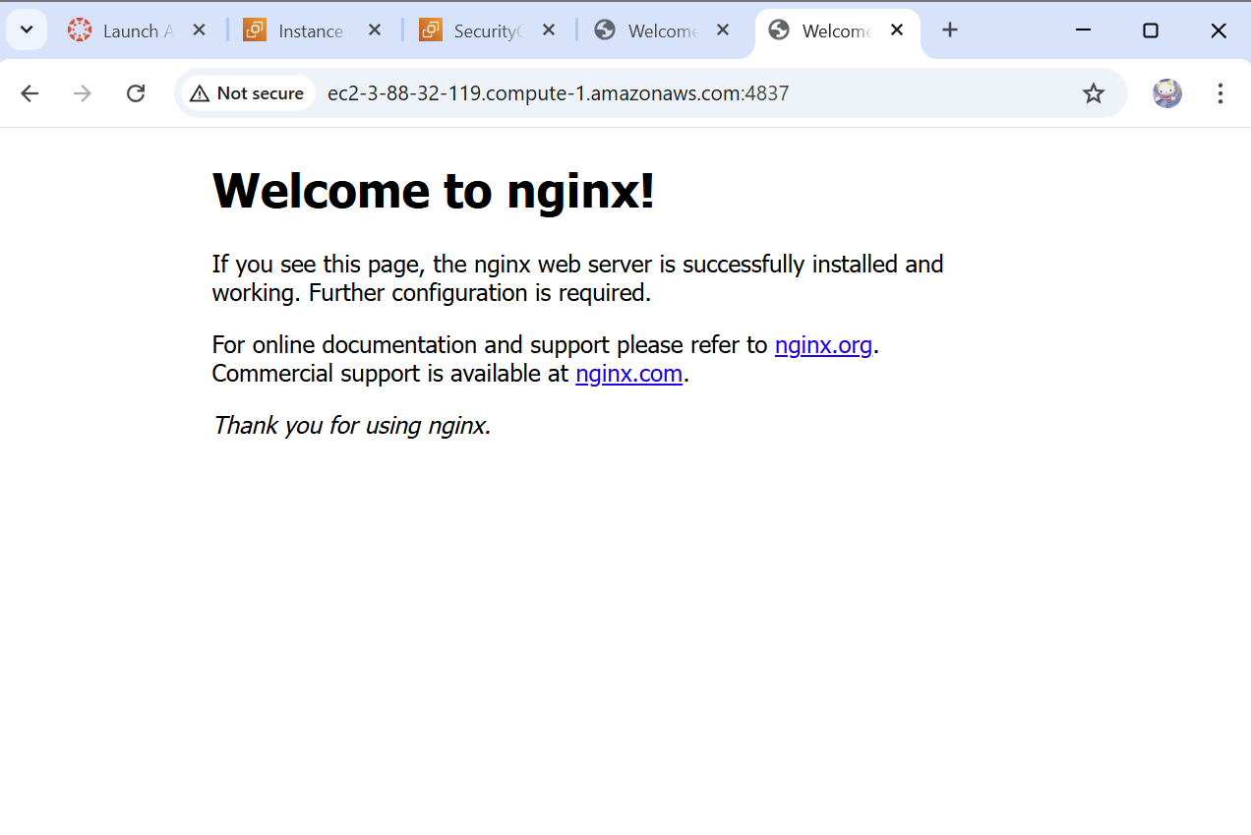
If you don’t care what port is mapped and want Docker to choose a free host port automatically, you can use the -P flag.
# docker run -d -P nginx
To see what port it was mapped to, check docker ps.
# docker ps
CONTAINER ID IMAGE COMMAND CREATED STATUS PORTS NAMES
a3340ce85db6 nginx "/docker-entrypoint.…" 3 seconds ago Up 3 seconds 0.0.0.0:32768->80/tcp, [::]:32768->80/tcp brave_edison
72c7036d6a5e ubuntu "/bin/bash" 3 hours ago Up 3 hours container-2
bd0fb7ba3039 ubuntu "/bin/bash" 3 hours ago Up 3 hours container-1
Navigating to the AWS DNS address on the generated port 32768 (http://ec2-52-23-158-184.compute-1.amazonaws.com:32768/), we get the nginx server page.
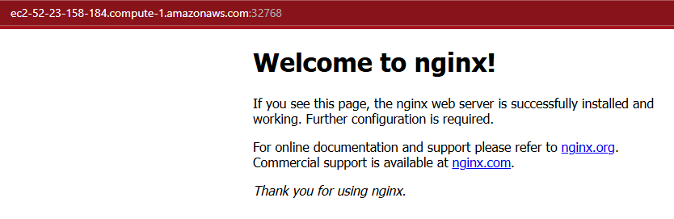
- Pre-Built Images
Pre-built Docker images are ready-to-use container images created and shared by Docker or the community, available on repositories like Docker Hub. These images contain pre-configured environments, applications, or tools, such as databases, programming language runtimes, or operating systems. Pre-built images save time and effort by eliminating the need to manually install and configure software inside containers, allowing users to focus on application development and deployment. They can be customized further by creating new images based on them.
The steps for a pre-built image are straightforward.
- Pull the image:
# docker pull {image name}
- Run the image:
# docker run -d {any other flags like port or volume mapping} --name {container-name} {image name}
A great pre-built image to download and run is called Portainer. Portainer is a lightweight, web-based management tool for Docker, Kubernetes, and other container platforms. It provides a user-friendly interface to manage containers, images, networks, and volumes without needing to use the command line. With Portainer, users can easily deploy and monitor applications, set up container environments, and manage multi-cluster setups. It simplifies container management for both beginners and advanced users, offering features like role-based access control and detailed monitoring.
- Create the volume Portainer will use to store configuration data. Name the volume portainer_data.
Command(s) used: | docker volume create portainer_data
Screenshot of commands being run: | 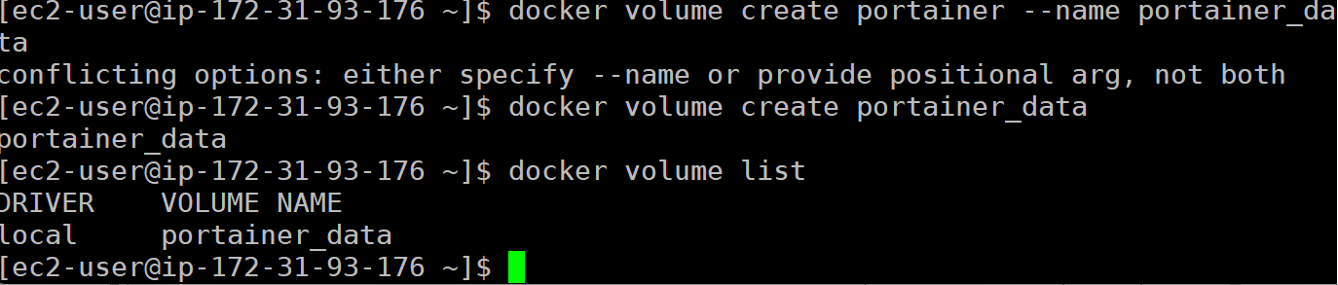
- Download and run the Portainer Server container (portainer/portainer-ce) with the following specifications:
  - Map ports (-p):
    - Container port 8000 to host port 8000
    - Container port 9443 to host port 9443
  - Name the container (--name) portainer
  - Map two volumes to the container (-v):
    - /var/run/docker.sock -> /var/run/docker.sock
    - portainer_data -> /data
  - Allow it to run detached (-d)
Command(s) used: | docker run --name portainer -p 8000:8000 -p 9443:9443 -v /var/run/docker.sock:/var/run/docker.sock -v portainer_data:/data -d portainer/portainer-ce
Screenshot of commands being run: | 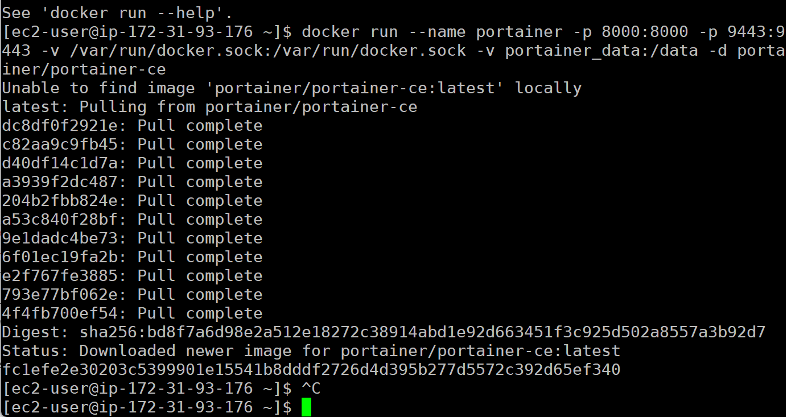
- Browse to your AWS DNS address on port 9443. Note that you will have to use https this time and proceed when you get the certificate or security error.
- You should be at the Portainer setup screen. Create a password for the admin user, then click “Create user.”
- In the Environment Wizard, select the “Get Started” option to use the local environment.
- Click on “Live connect” on the local Docker instance.
Screenshot of Portainer in browser: | 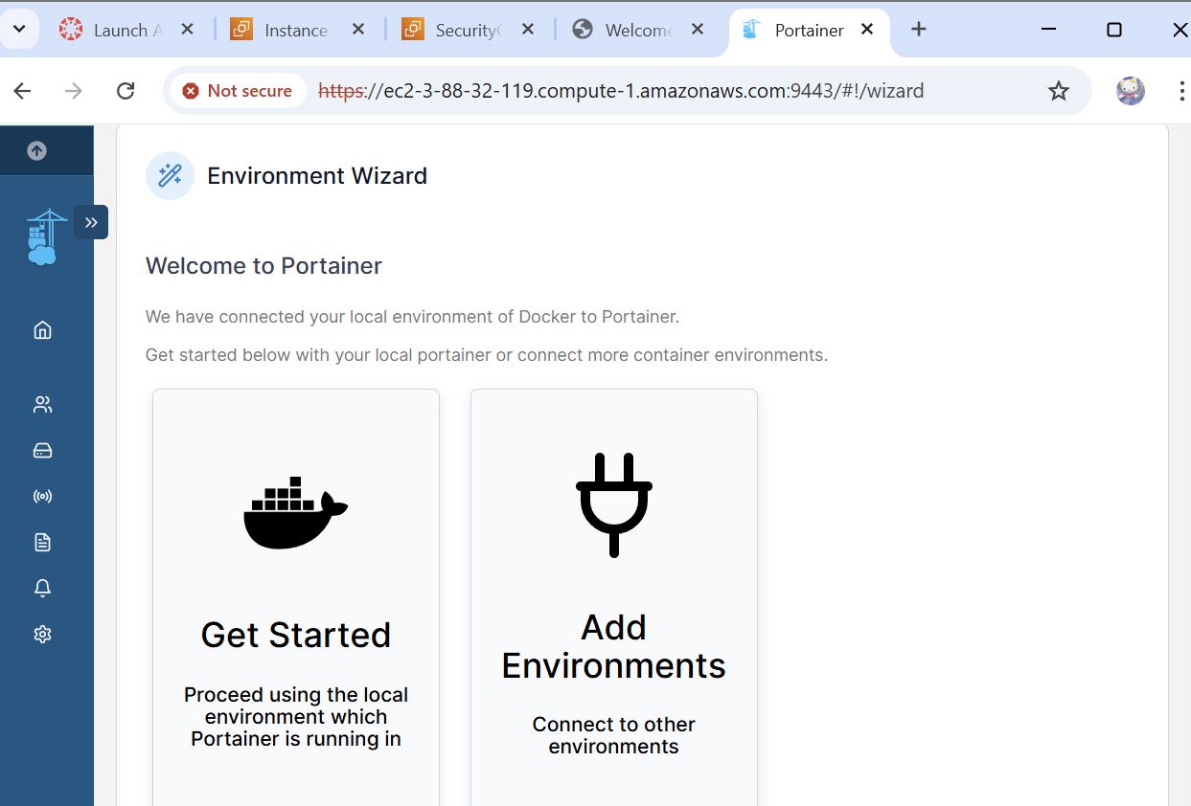
- This is a web-based interface for interacting with Docker. On the left menu, there are some options:
  - Containers à Shows the running containers (docker ps -a)
  - Images à Shows images on the system (docker image list)
  - Networks à Shows Docker networks (docker network list)
  - Volumes à Shows Docker volumes (docker volume list)
- Create a new container by navigating to “Containers” then selecting the “+ Add container” button in the upper right. 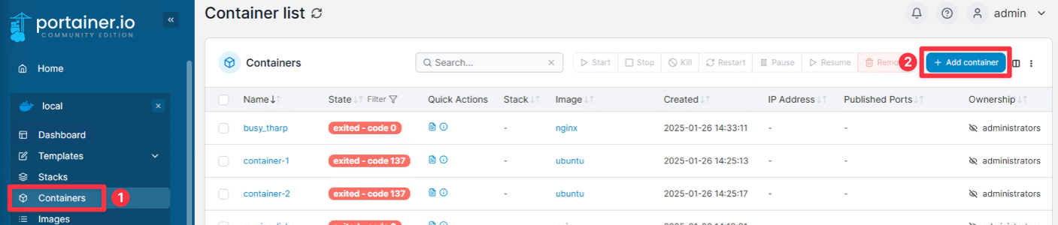
- Name the container “portainer-test” with “ubuntu:latest” as the image, scroll down to “Advanced container settings.” Select the “Interactice & TTY” option next to Console, and click “Deploy the container” just above “Advanced container settings.”
- Click on “portainer-list” in the list of containers to look at the container in depth. You can see the IP Address, status, ID, options to start, stop, kill, pause, remove and more.
Screenshot of portainer-test Container details: | 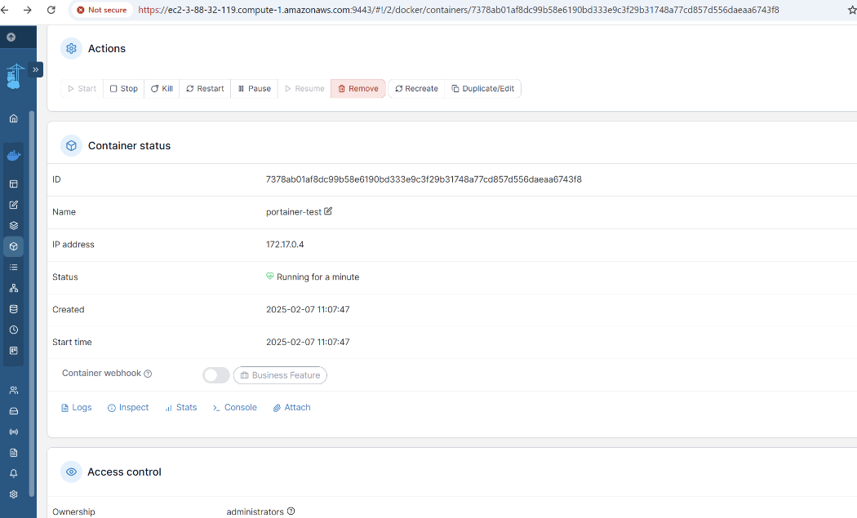
There is a lot that Portainer can do to help simplify the management of Docker and containers. If you are interested in learning more about it, check out the documentation at https://docs.portainer.io/.
- Reflection
- Reflect on your experience completing this lab. Consider the key concepts you learned about containerization, networking, and storage using Docker. How did the hands-on tasks enhance your understanding of these technologies, and what challenges did you face during the setup or execution? Additionally, think about how containerization could be applied to real-world development or deployment scenarios.
I found that I faced problems mainly with the set up of mt security groups in AWS. I need to pay more attention to the different types of access in more detail. Something that I always have some issue with is syntax errors, I found that I kept making simple mistakes that gave me an error response and it was a challenge to see a tiny grammar mistake in my code. I was also thankful that for the most part the components of containerization, networking, and storage have a lot of the same basic components, and for me the struggle I faced was working through what makes each component unique.

